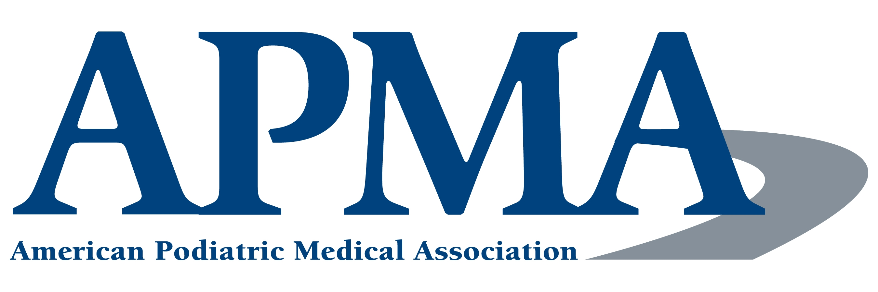
CODE OF CONDUCT: ONLINE COMMUNICATIONS
August 2012

This Code of Conduct: Online Communications (Code) sets forth the expectations of the American Podiatric Medical Association (APMA) for its members and volunteer leaders, component and affiliated societies, corporate sponsors, advertisers, and others who do business with APMA with respect to the use of social media communication channels, including but not limited to Twitter, Facebook, LinkedIn, YouTube, Google Plus, Tumblr, and Pinterest. The APMA has a proud tradition of advancing podiatric medicine in the eyes of the medical profession, health-care consumers, legislators, and others for more than a century. Similarly, APMA has an excellent reputation for being worthy of earning and maintaining the trust of its members and the public. Protecting that reputation is a shared responsibility, particularly in an era of instant online access to information about the profession and its association. In addition, APMA members are reminded that the APMA Code of Ethics expects truthful disclosure of actual and potential conflicts of interest in all communications.
(Note: A separate social media policy has been developed specifying the expectations for online communications use by staff and others working for APMA.)
Content Guidance
Responsible use of social media is an effective way for APMA to engage targeted audiences and deliver pertinent messages in real time. All of APMA’s social media platforms, despite privacy settings, are public forums with their own etiquette and policies. If you have specific questions regarding any of APMA’s social media platforms, contact the APMA Communications Department at communications@apma.org for information.
APMA Social Media Communications Decorum
How you communicate on social media platforms will depend on whether you are doing so on behalf of APMA, in connection with an APMA-sanctioned project, or for your own personal purposes. When you communicate via any of APMA’s social media platforms, health-care consumers, legislators, and other members of the public may view your comments to be representative of the views and opinions of APMA. As a practicing or retired podiatric physician, student, resident, faculty member, volunteer leader, or executive, your online conduct reflects on not only the association but also the profession as a whole. Please keep this in mind when commenting, replying, or creating online discussions.
All opinions, beliefs, and views stated on APMA social media channels are to be respected. The podiatric profession includes a diverse and ever-changing community of interests. Please remember to be polite and courteous to everyone within APMA’s online community no matter your stance on a particular topic that is being discussed.
When communicating on social media platforms operated by APMA, you are expected to follow these guidelines:
Be Transparent: Clearly identify whether you represent a particular organization or only yourself in your communications.
Be Responsible: Never post content that is damaging to APMA’s standing as a nonpartisan, nonprofit organization, or otherwise jeopardize the reputation of APMA or the podiatric medical profession. Responsible online communication includes, but is not limited to:
- avoiding posts of a harassing or threatening nature toward colleagues, APMA staff and members, volunteer leaders, corporate sponsors, advertisers, or any other persons or organizations; any form of intimidation or harassment on any of APMA’s social media platforms is grounds for immediate removal of the user from the platform;
- refraining from profanity of any kind;
- avoiding malicious, defamatory, and/or purposely inaccurate posts, discussions, tweets, videos, and comments about podiatric medicine, podiatrists, or the medical profession in general; and
- ensuring that an aggressive tone is not perceived in a communication, such as using unusual font colors, or using all capital letters, which is often interpreted by readers as screaming or yelling.
Be Accurate: Although you may be expressing your personal opinion, back up your statements with facts whenever possible and cite any data you provide.
Respect Copyrights and Confidentiality: Only post what you have permission to post. Make sure you have permission to post any copyrighted items (e.g., images, logos) or potentially confidential information. If you are unsure of what you are or are not allowed to post, please contact APMA. If there is an embargo placed on certain content from the APMA Communications Department, please respect the rules that are in place on that piece of content.
Inappropriate Online Communications
APMA reserves the right to determine whether any content posted on any of its social media accounts violates its expectations for proper online communications decorum. APMA reserves the right to remove inappropriate content, moderate future posts, and take other action, including termination of membership in certain social media groups.
The following levels of user access privileges are defined for APMA’s social media channels:
Full Access User - When you join any of APMA’s social media channels, including but not limited to Twitter, Facebook, LinkedIn, and YouTube, you will have full access as a user. This means that you will be able to post discussions, comments, replies, videos, etc., without prior consent or approval from the group’s moderator.
Monitored Access User - If a user is deemed to violate the expectations for appropriate communications decorum, the user will receive notification from the moderator of the APMA social media platform noting such, and the user will be asked to refrain from repeating the offending action. As a result, the user’s access privileges in APMA’s social media forums may be changed from “full access” to “monitored full access” for 30 days. The user’s posts will be subject to approval by the moderator prior to publication. At the end of the 30 days, “full access” user status will be reconsidered for reinstatement.
Restricted Access User - If, after an initial notification and change of the user’s status to “monitored full access” status, the user continues to violate the expectations for appropriate communications decorum, a second message from the moderator of the APMA social media platform will be sent. Consideration will be given to changing the user’s privileges to “restricted access” for a minimum of six months. Similar to “monitored full access,” restricted access users must submit all posts for approval by the moderator prior to publication. At the end of the six-month period, “full access” user status will be reconsidered for reinstatement.
Termination from Group - At its discretion, APMA reserves the right to terminate individual access to any of its social media platforms for reasons including, but not limited to the following:
- Repeated disregard in complying with the expectations for proper online communications decorum
- Posting of harassing, threatening, or intimidating messages
The APMA executive director shall determine all final decisions regarding user access privileges for APMA online communications platforms.

Approved: APMA Board of Trustees
August 2012
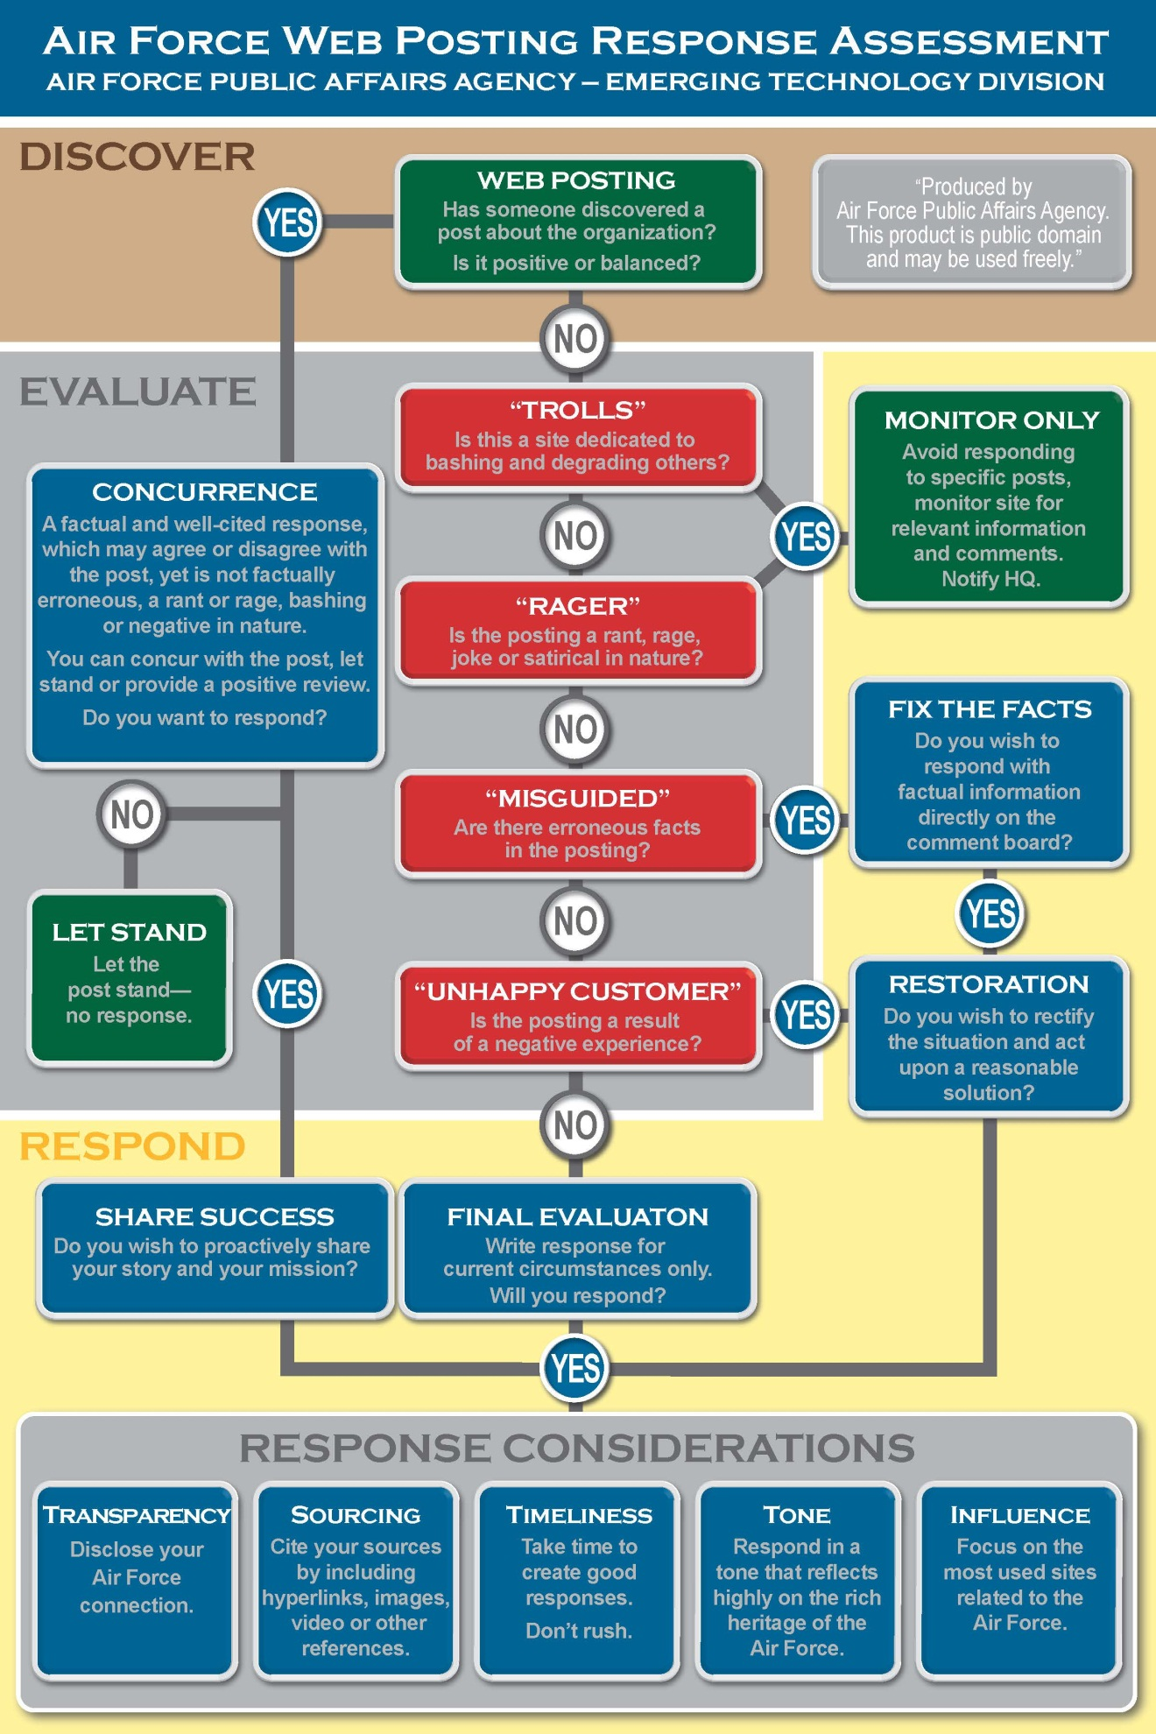
Infographic is courtesy of the Air Force Public Affairs Agency.

